Big Mountain Resort Ticket Pricing

## Set up and Data Wrangling

We started out with the question: “How can we correctly set ticket prices and cut costs elsewhere to offset an additional $1.54M in operating costs before this season?”. I started by removing irrelevant data points and analyzing data from states and ski resorts across the country for price by states and price for weekdays/weekends:

I found most states are around the same pricing with Montana falling toward the middle to lower end in pricing. There were several points where weekend and weekday prices are equal and the most variance occurs when tickets are under $100.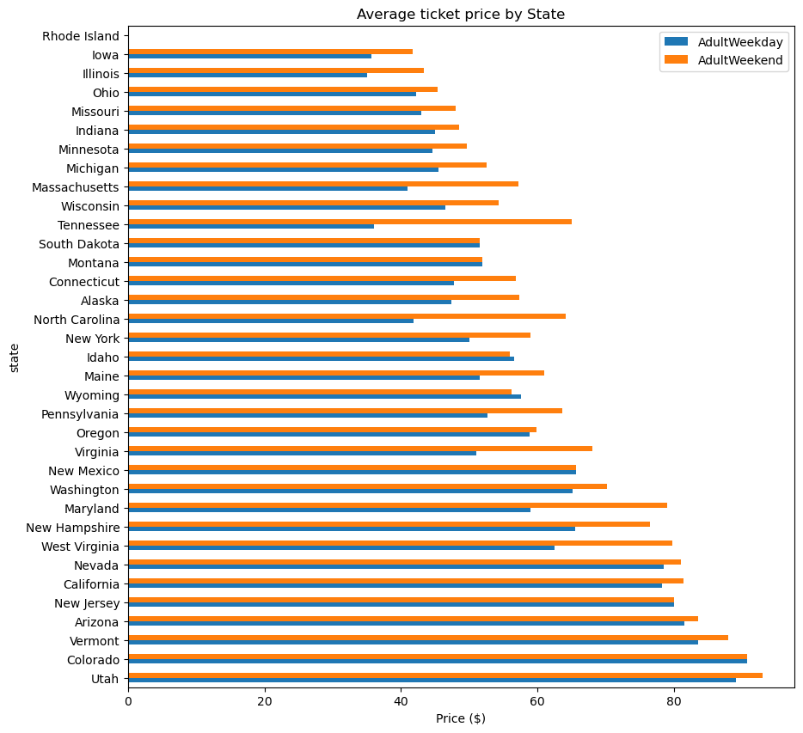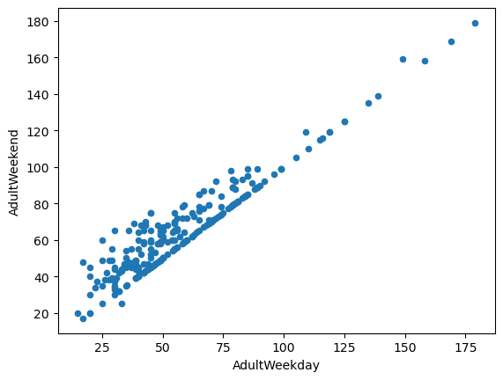

## Exploratory Analysis

During the exploratory analysis, my main goal was to find the correlation between features of ski resorts and ticket pricing. This will help us decipher what affects ticket pricing the most. First , I found that states had no significant correlation with ticket prices:

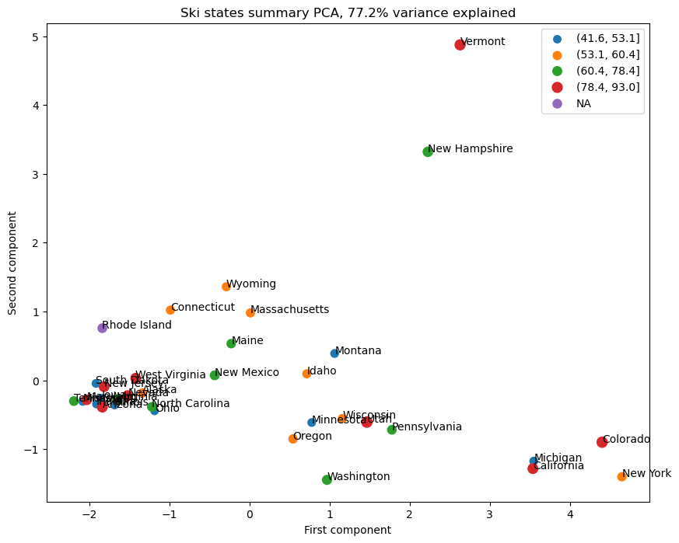

Next, I looked deeper into the features of the ski resorts to see how they impacted ticket prices.

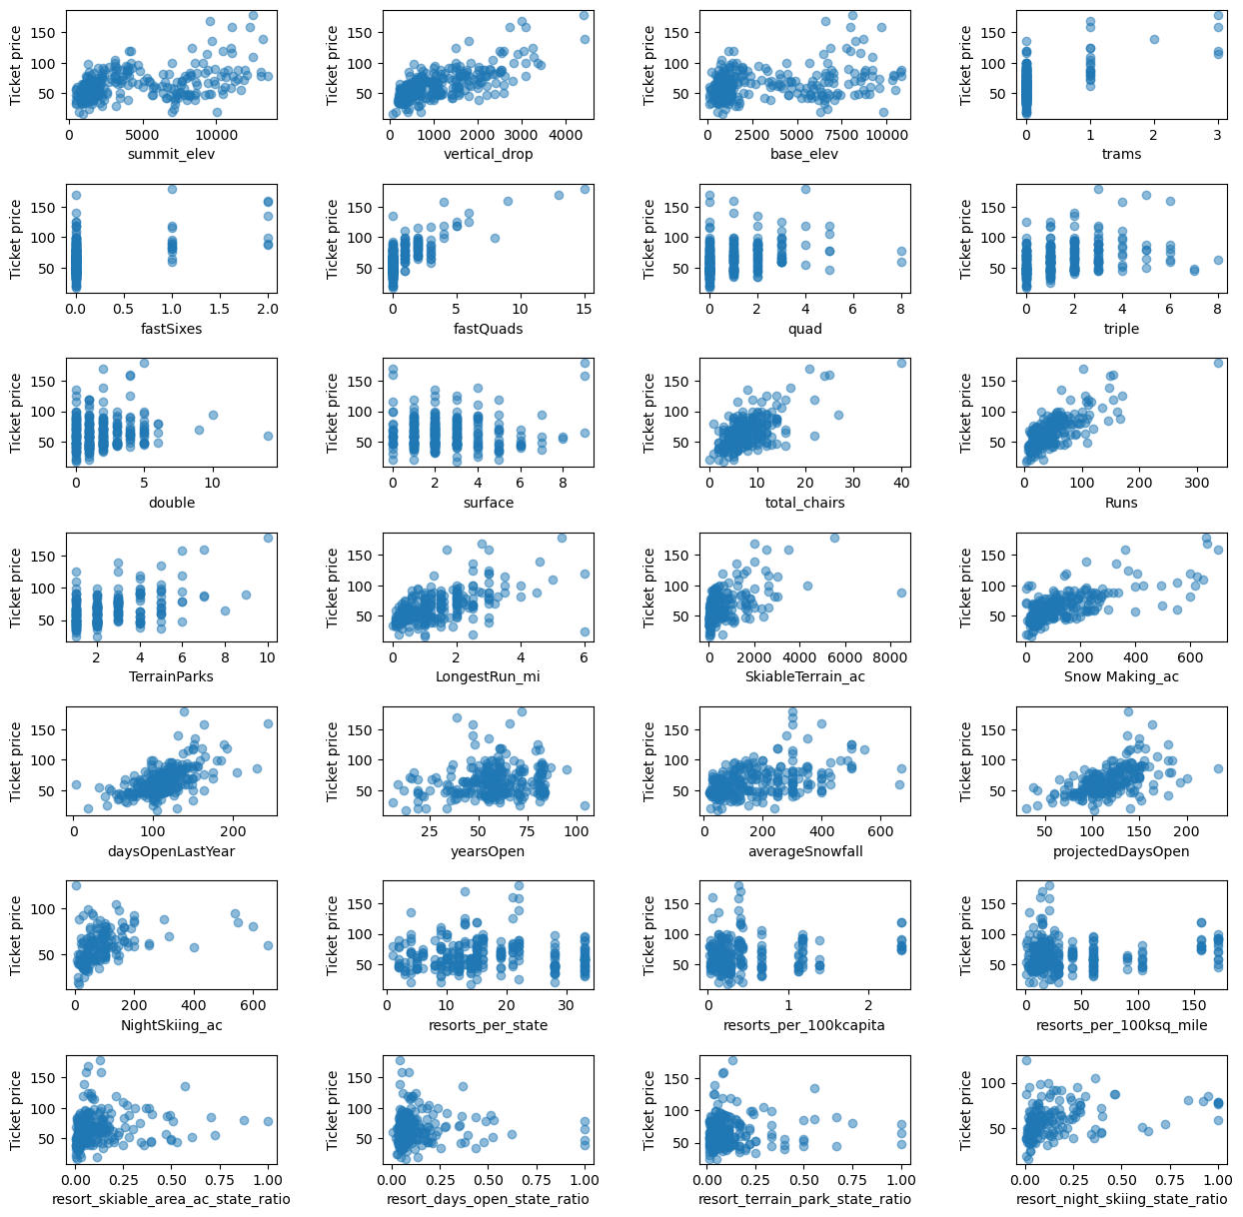

In this heatmap, I found that runs, total chairs, fast quads, and vertical drop had the strongest correlation wth ticket prices.

## Preprocessing and Model Selection

Next, I tested both linear regression model and a random forest model to see which to move forward with. Based on the average of known values, our mean absolute error on ticket prices is about $19. In the linear regression model, I found a mean absolute error to be just under $12 while the random forest model had a mean absolute error of $9.54. I decided we should proceed with the random forest model as it is more accurate. The random forest model indicated the most dominant features for ticket price were fast quads, runs, snow making area, and vertical drop:

## 

## Modeling

Using this model we found that Big Mountain Resort had a modeled ticket price of $95.87 compared to a current price of $81. I further verified this by seeing where Big Mountain ranked in market context, seeing it ranked highly in key metrics such as snow making area, number of chairs, fast quads, runs, longest run, and skiable terrain area.

Next, I took the business suggestions and used our model to see what type of affect the proposed changes would have. There was no difference in revenue and ticket price by closing one run: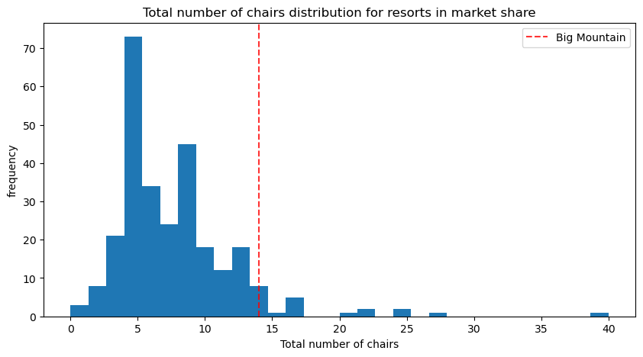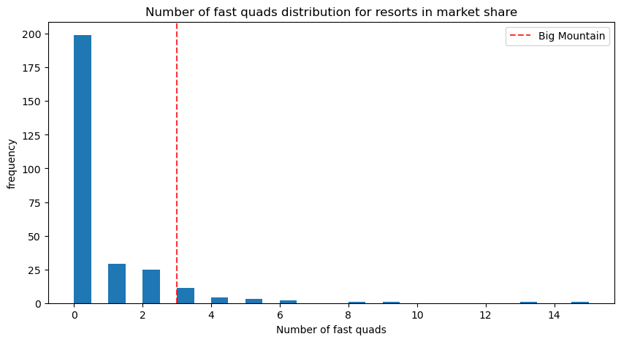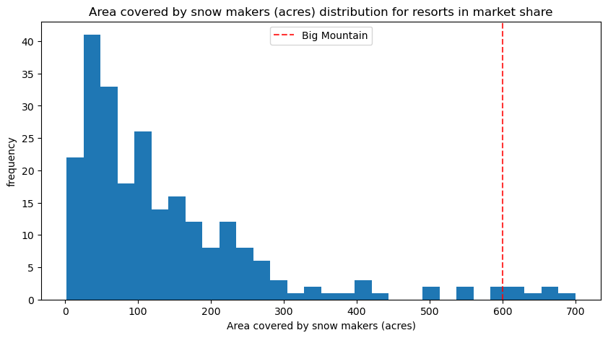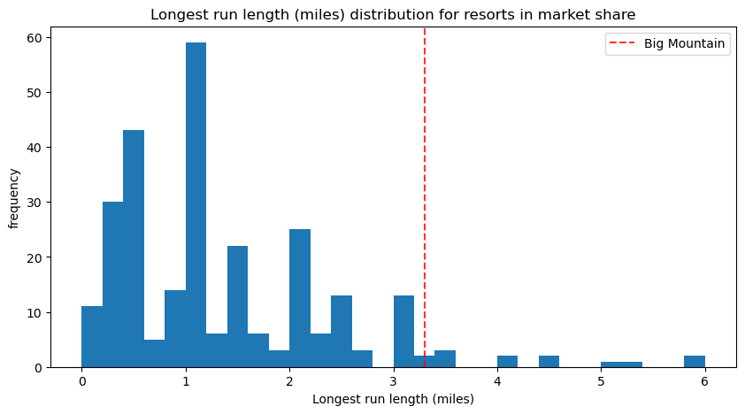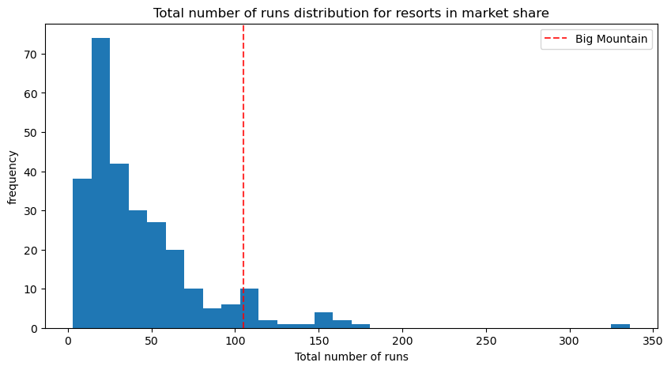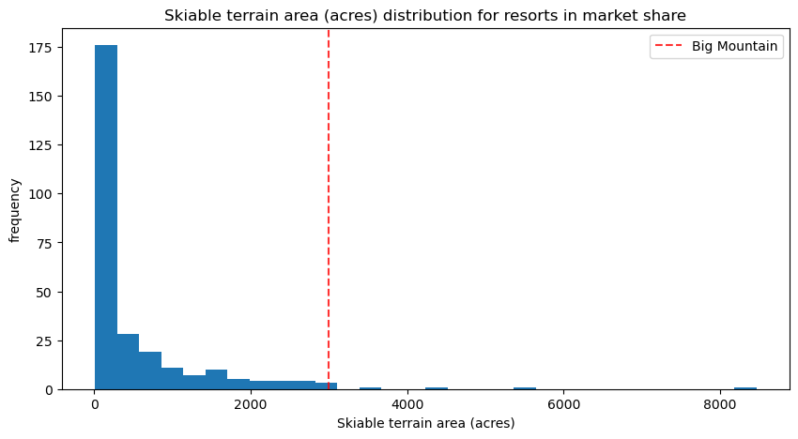

In the other scenarios that included adding a run, increasing vertical drop, and installing an addition chair lift, we found there would be justification for increasing tickets by $1.99 which would result in $3,474,638 in additional revenue for the season. There was no difference for additional snow making area or increasing the longest run by .2 miles.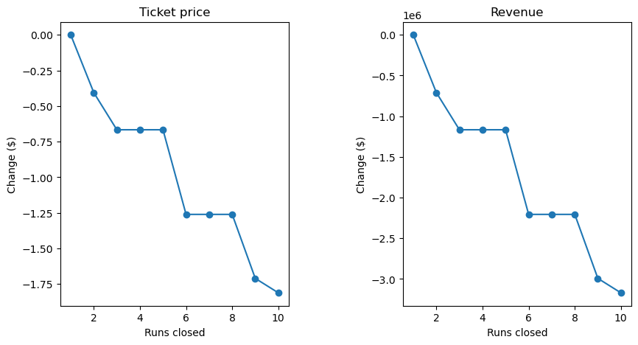

## Recommendation

The additional operating costs of the new chair lift are $1,540,000. With our average visitors, even increasing the ticket price $2 would result in $3,474,638 additional revenue. I would suggest closing our least popular run since we found closing one run has no impact on ticket prices. We can close the run "for construction" and see how the resort performs. I would also suggest raising prices by $2 since it is a small amount that would not deter skiers and would cover the costs of our new chair lift.